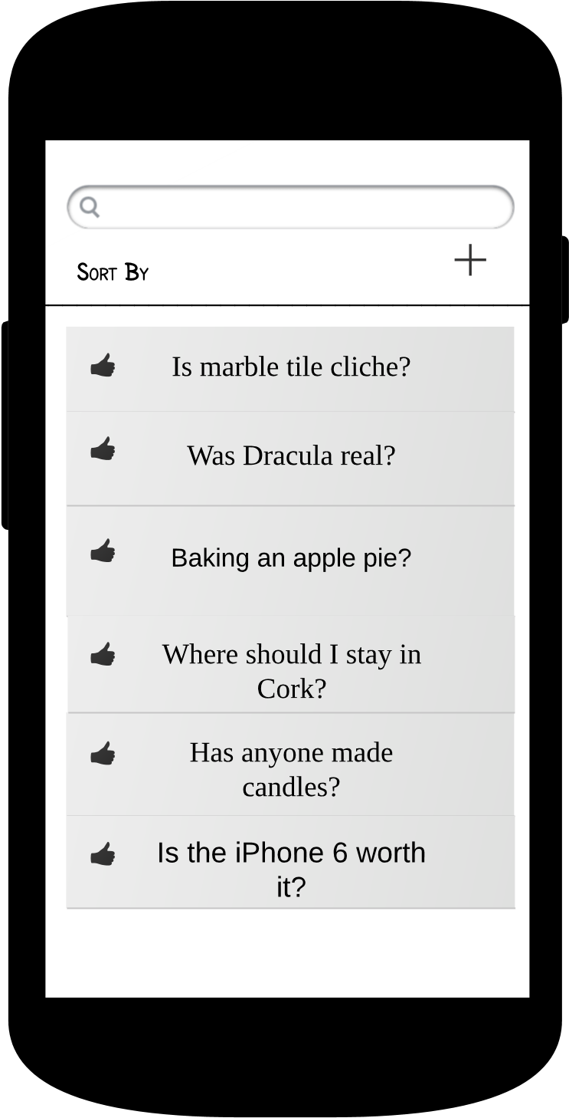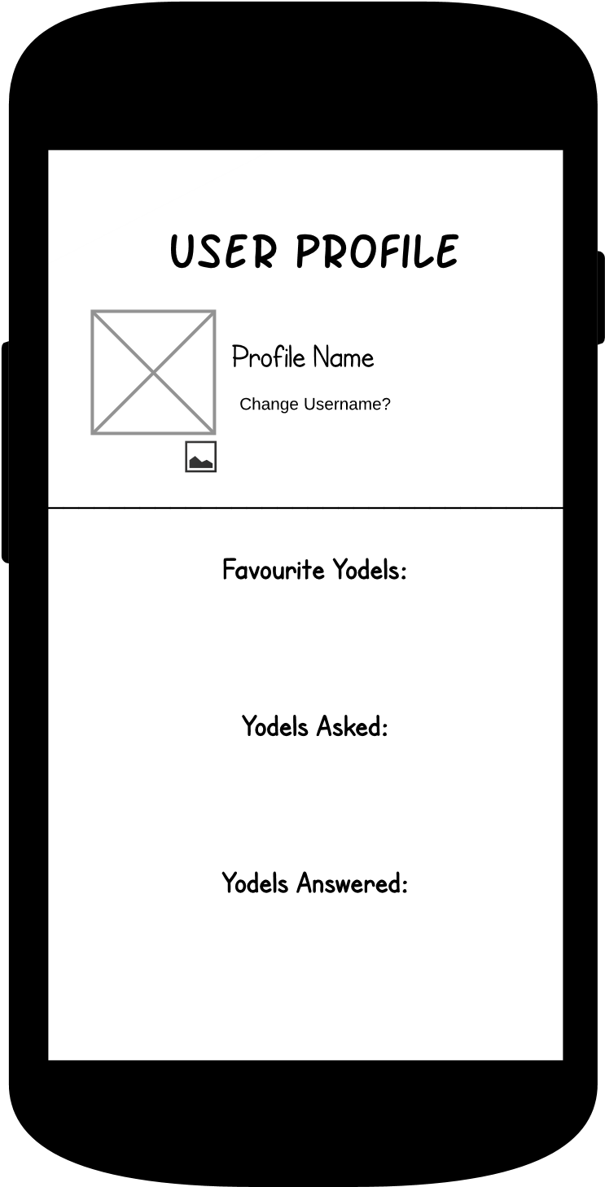

User can click on the picture button to change their user profile picture or can click change username to bring up the prompt to change user name.

Legend:

Click

Long Click

User clicks on the Login button after entering their username. This automatically takes them to the forum topics page.

Pressing the gear at the top right hand corner brings up the user profile page. Clicking on a topic brings up Yodels.

Pressing



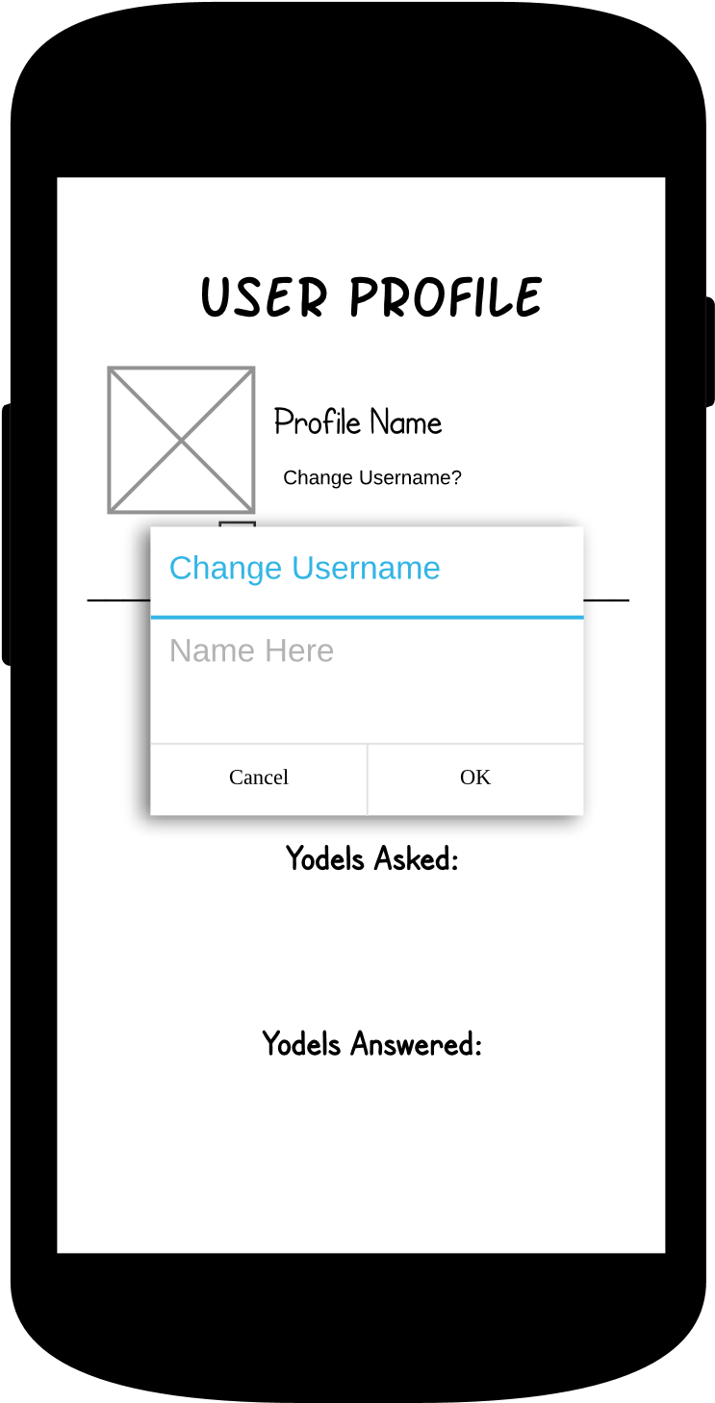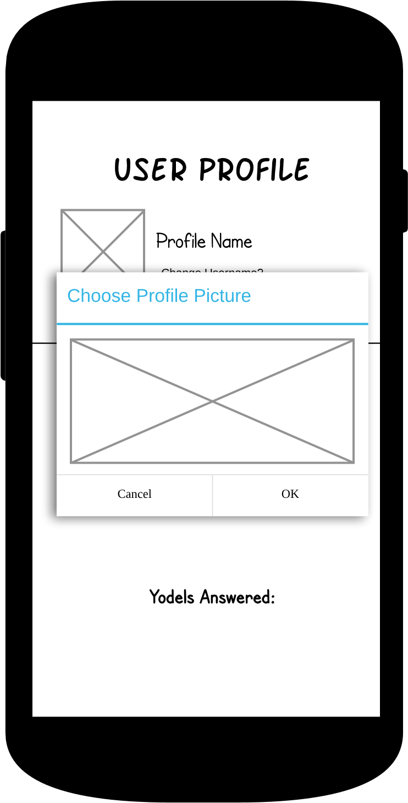

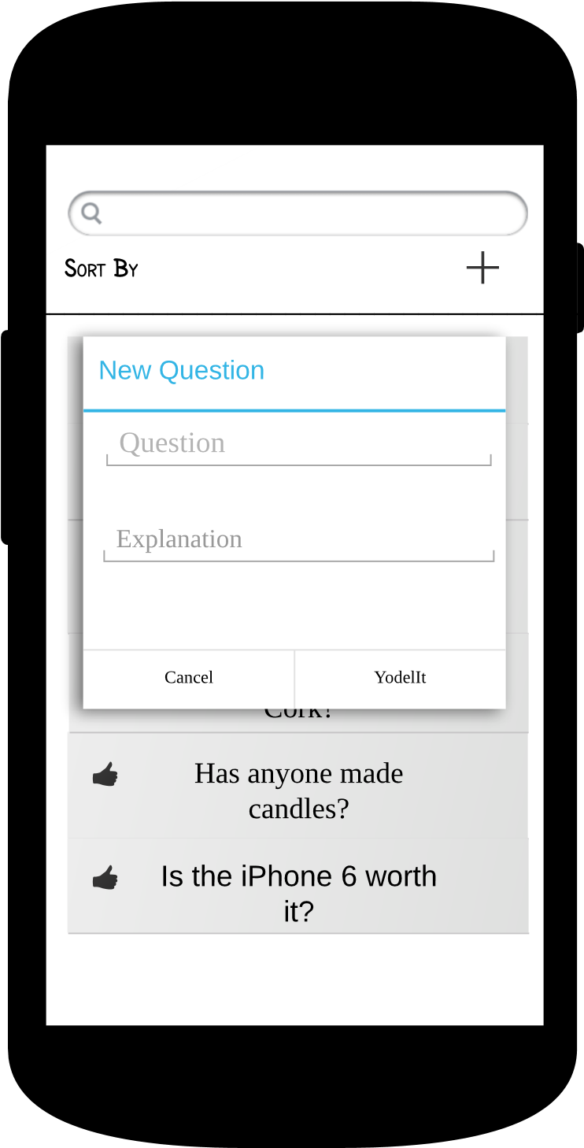

In a Yodel List page, pressing sort by brings up a list of ways to sort the Yodel List.

Clicking on the plus button at the top brings up the new Yodel dialogue box. Here you can enter a question with a short explanation

Long clicking on a Yodel allows a user to favourite the Yodel. This is also true on an Echo.

Clicking directly on the Yodel brings up the Yodel and it’s Echos.

Yodel

Yodel List Page

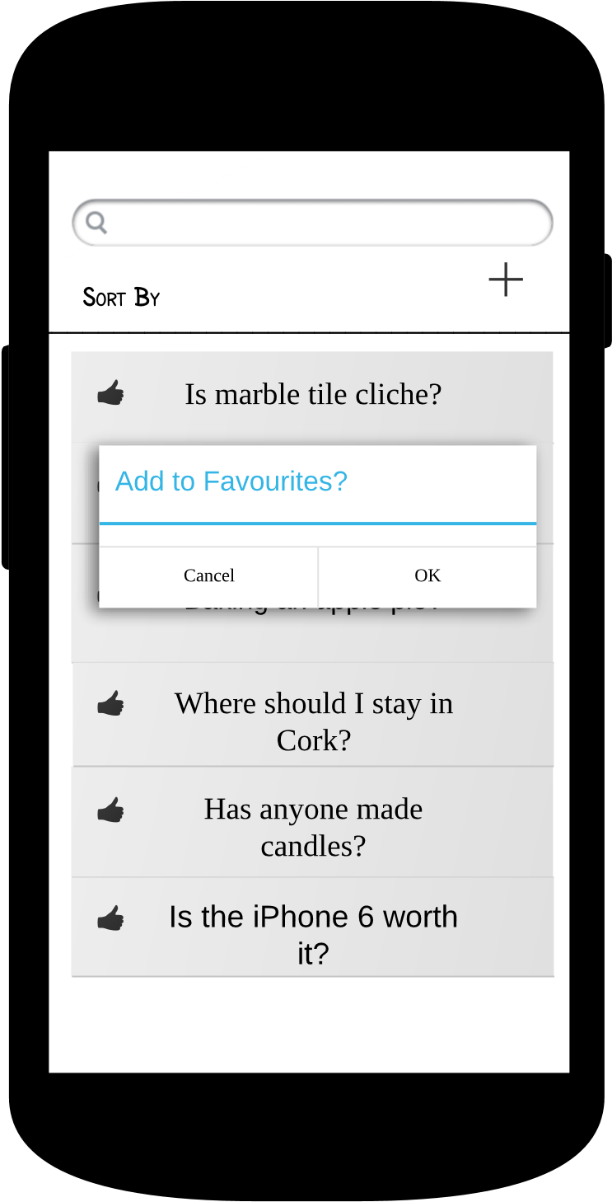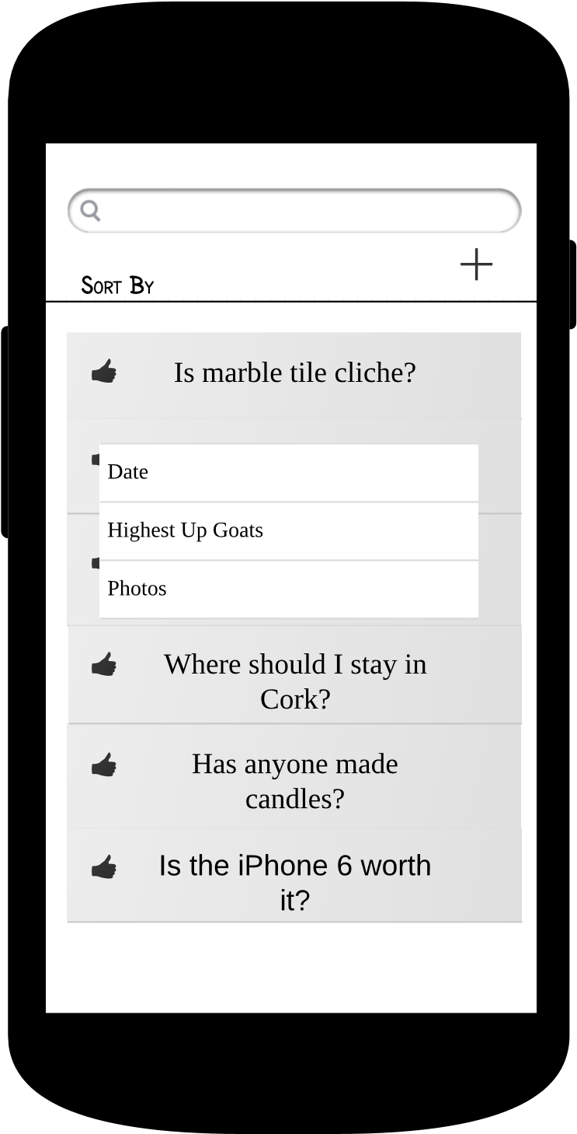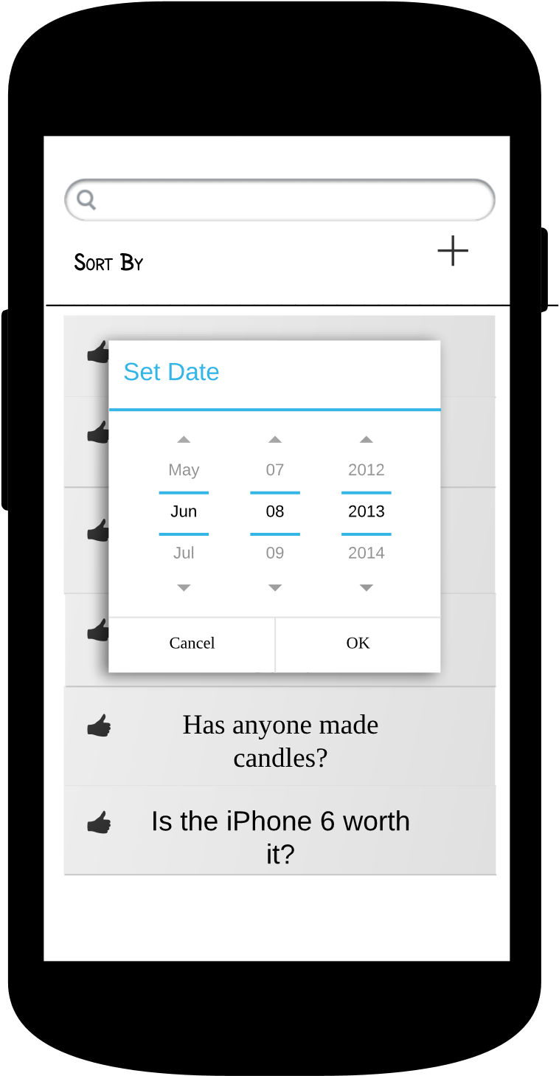

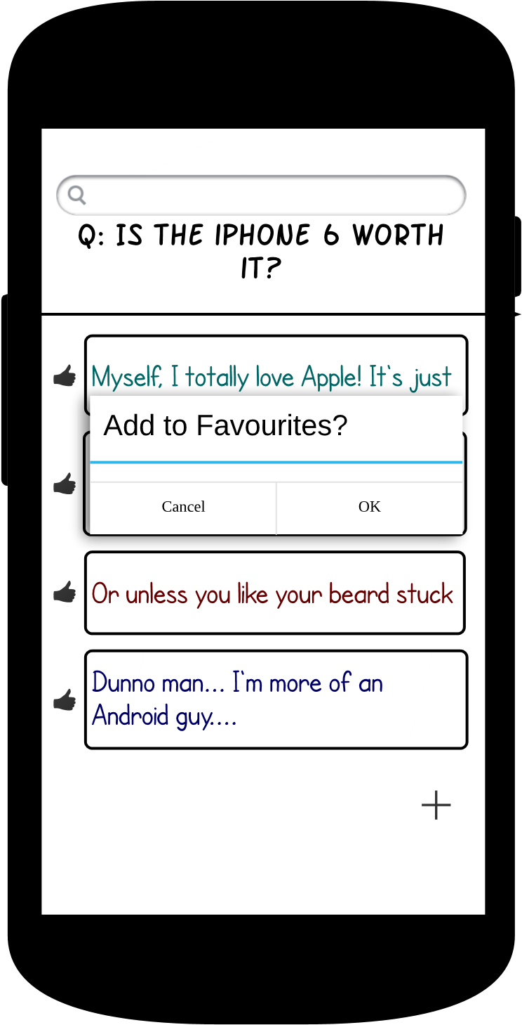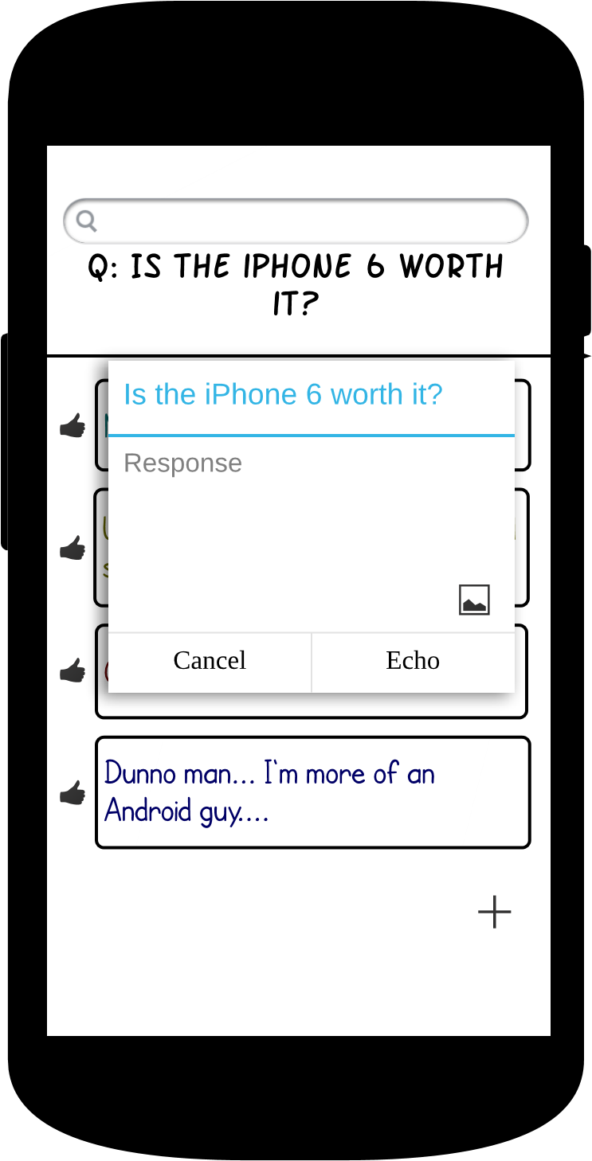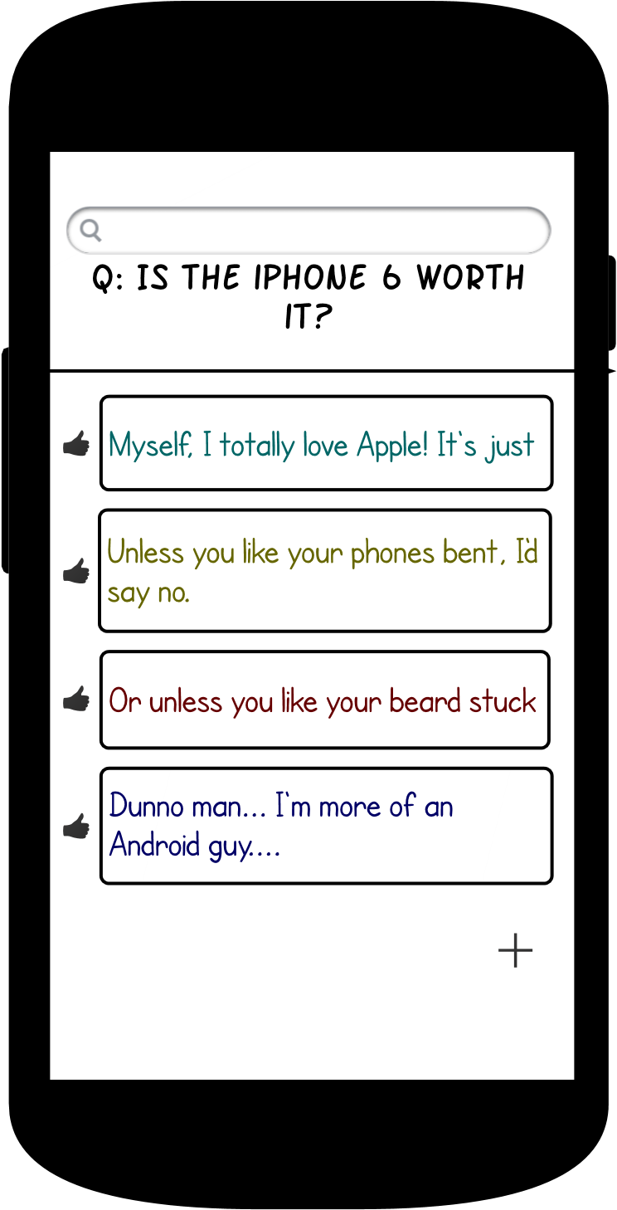

Pressing the plus button brings up the add Echo dialogue. Here users can reply to Yodels and add pictures to their responses.

